Appendix I: Project Procedures
Project Procedures
________________________________________________

The primary software used on this project will be Algor for static stress analysis and Adams for dynamic stress analysis. SmartSketch will be used in calculating geometries for the steering system. Pro Engineer will be used for CAD drawings. Microsoft Word will be used for all typed documents and Microsoft Power Point will be used for all presentations. The current format for group presentations will be used for all presentations associated with this project.
Typed documents more than one page in length
will be numbered at the bottom center. The date will appear on the cover page along with the names of the group members and the title of the document. All documents will be typed in 12 point Clarendon font with a 14 point bold header with the title of the document as seen on this document. The SAE 4WS Cover Page will be used as the standard cover page for all documents generated.
Meetings will be held every Tuesday and Thursday in the second floor computer lab. Any additional meetings will be called by the group leader Kevin Eady when needed. Sponsor meetings with Dr. Hollis will be held every other Monday at 10:00 and meetings with Gary will be held weekly if possible. The topic of these meetings will include but will not be limited to the scheduled topic for the week of the meeting. Any future plans or unresolved issues should also be discussed. All new data or information will be looked at critically with respect to the project. Any design decisions will be made by a majority vote during meetings. All meetings will be attended by all members and all members will be on time. If any member is not present during a meeting that member relinquishes his vote for any topic voted upon during his absence.
All members will have their assignments completed 3 hours prior to the due date to allow time for proofreading and corrections to be made by other members of the group. If any problems arise and the assignment cannot be completed on time inform Ken Brown as soon as possible.

Appendix II: Project Scope
Project Scope
_______________________________________________

The purpose of this project is to design a four-wheel steering system for the SAE Mini Baja car. Currently the Mini-Baja car has an inadequate turning radius which hinders the car’s performance during competition. In addition the current steering system is too fragile for serious off-road applications. These problems must be fixed in order to effectively compete in the SAE Mini-Baja competition.
This project will entail a redesign of the current steering system from a front wheel to an all-wheel design for improved integrity and reliability. A opposite wheel steering and parallel wheel steering will be considered to best meet the needs of the customer. As per the customer, the SAE club of Florida State University, the system should cost less than $500 due to the low amount of funds available. The design should be as lightweight as practically possible so as to not hinder the performance of the vehicle. The system should be designed for application on either the Formula SAE and Mini-Baja cars with only minor modifications. The geometry and ergonomics of the cars must also be considered so as not to interfere with mechanical components or driver comfort/performance. Lastly the maximum possible loadings must be considered and the design must compensate for these. Failure modes and points of possible failure should be identified and compensated for and a reasonable factor of safety applied. FEM will be used to determine the maximum loading and the points at which these loads act. Motion analysis will be conducted using Pro-Mechanica or Adams car to help identify the flaws in the design.
This steering system will be greatly improved over the current design in both turning radius and strength. It will allow the driver to improve his performance by giving greater stability and maneuverability during off-road use and increased integrity while navigating over obstacles. All this will be accomplished within the five hundred dollar limit allowed by the customer as well as meeting all current and future needs required of it.

Appendix III: Needs Assessment Report
Needs Assessment Report
_______________________________________________

The product to be designed by this team will have to meet several straightforward objectives set forth by the sponsor of this project, the SAE club of Florida State University and Dr. Patrick Hollis. The objectives of the project must be met while satisfying fairly strict limits regarding the cost, strength, reliability, weight and finally application of the product.
The most important requirement of the product is simply that it reduces the turning radius of the Mini-Baja car already designed by the SAE club for use in intercollegiate club competitions. In this case it has been determined that a 5’- 6’ turning radius will be needed to effectively compete in any off-road course competitions.
The restrictions that must be met while fulfilling the primary objectives are that it must come in under budget, must not be too heavy, must endure the expected forces incurred in such competitions and must be able to be applied to the formula car with only minor modifications.
The budget for this project has been set at five hundred dollars. It is anticipated that this product can be completed at or around this figure. The weight restriction has been left undefined and it is up to the group to study and determine a proper maximum weight for such a system. The system must be designed to endure the maximum expected forces that can be expected. Again, it has been left to the design group to determine these forces and design for them. The application from Baja car to the Formula SAE car is expected to be somewhat difficult as the cars are very dissimilar in geometry and construction but we are still confident in our success. It is still to be determined if the system must function the same on both cars (i.e. opposite wheel vs. parallel wheel steering) or must be designed and applied to both vehicles.
The project has been left fairly wide open in regard to restrictions placed upon the design group. With the exception of the budget there seems to be little deterrent to meeting the needs of the customer.

Appendix IV: Initial Product Specifications

Specifications
________________________________________________

Component | Specification
Maximum Turning Radius | 7’
Forces to Withstand | TBD
Budget | $500
Front Wheel Angle(max) | 30 degree
Rear Wheel Angle(max) | 15 degree
Weight | TBD
Front Rack Travel | 5”
Front Rack Length | 25”
Steering Arm Length | 3.5”
Tie Rod Length | 7.07”
Rear Rack Travel | 5”
Rear Rack Length | 25”

Appendix V: Concept Generation
Concept Generation

Four Wheel Steering Configuration

1. Parallel Wheel Steering:
Pro: Stable during high speed turns.
Con: Turn radius requirement cannot be reasonably met
2. Opposite Wheel Steering:
Pro: Small turning radius can be easily achieved
Con: Unstable during high speeds if wheel angles are to steep
3. Dual Configuration System
Pro: Provides Parallel steering at high speeds and opposite steering at
low speeds
Con: Cannot be achieved on given budget, impractical except for
highly specialized cars

Decision: Opposite Wheel Steering
Steering Systems

Front Steering:

1. Rack and Pinion: 5” of travel, 25” total length
Pro: Common system, easy to use, easy to modify, cheap, durable.
Con: Cannot change pinion easily
2. Re-circulating Ball Bearing: 5” of travel, 25” total length
Pro: Fairly common, durable
Con: More parts involved, expensive, harder to use

Decision: Rack and Pinion

Rear Steering:

1. Rack and Pinion:
Pro: Common system, easy to use, easy to modify, cheap, durable.
Con: Cannot change pinion easily
2. Re-circulating Ball Bearing:
Pro: Fairly common, durable
Con: More parts involved, expensive, harder to use

Decision: Rack and Pinion

Steering Angles & Ratios:

Front Wheel Angles

1. 22.5 degrees:
Pro: Current front wheel angle, would only need to strengthen front
steering system instead of redesigning
Con: Wheel angle not large enough, would large front:rear wheel
ratio to achieve desired turning radius
2. 30 degrees:
Pro: Should not present problem of toggle condition during
competition, can achieve desired turn radius with a 2:1 front:rear
ratio, comparable to most passenger car’s front wheel angle.
Con: Will not allow as tight a turn as a 35 degree angle will.
3. 35 degrees:
Pro: Very tight turns possible, desired turn radius can be met
with a smaller front:rear ratio
Con: Larger than any front wheel angle found during research, may
present toggle condition when hitting obstacles at full turn

Decision: 30 degree front wheel angle

Front to Rear Ratio

1. 3:1 ratio:
Pro: Small ratio, because rear wheels turn very little in reference to
front wheels the vehicle should be fairly stable in turns
Con: Turn radius cannot be satisfied unless the front wheel angle is
very large
2. 2:1 ratio:
Pro: With a 30 degree front wheel angle the back wheels will be 15
degrees at a full turn, good stability, turning radius can be easily met
Con: Less stable than 3:1 ratio
3. 1:1 ratio:
Pro: Very small turn radius can be achieved
Con: Highly unstable

Decision: 2:1 front to rear ratio

Rear Wheel Angle

Decision: Defined by the front:rear ratio

Linkage / Shaft Connection

1. Shaft connecting front and rear rack. Rotated as the front pinion
turns the front rack. Front gear is twice the diameter of the rear
pinion.
2. Shaft connecting front and rear rack. Shaft rotated by turning the
shaft directly from the steering column. Front pinion is twice the
diameter of the rear pinion.
3. Linkage from front right to rear left steering system. Second linkage
from front left to rear right steering system.
4. Set of shafts from front to rear with a planetary gear set providing a
variable gear ratio (higher ratio for hard turns, lower ratio for soft
turns).

Decision: Shaft connecting front and rear rack. Shaft rotated by turning the shaft directly from the steering column. Front pinion is twice the diameter of the rear pinion.

Ackerman/Standard Configuration

1. Ackerman Steering:
Pro: All wheels travel along different arcs allowing each wheel to
pivot about the same point, better traction, less tire wear.
Con: Very difficult to design for cars both left and right turns.
2. Standard Steering:
Pro: Works well on passenger cars, drivers familiar with feel of
standard steering, design both front wheels with same angle, design
both back wheels with same angle
Con: Less traction during turns, tires wear faster

Decision: Standard Steering Configuration

Appendix VI: Force Analysis Graphics
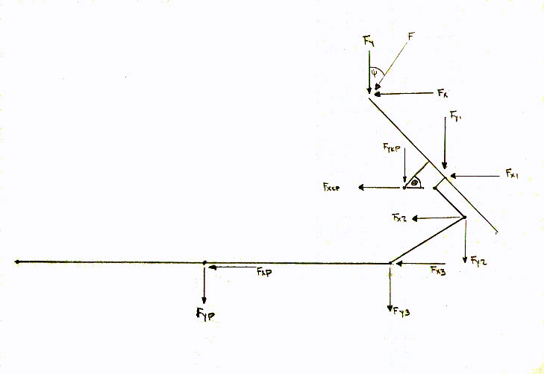
Force Analysis Graphic for Entire System: Included for Force Analysis Notation Purposes

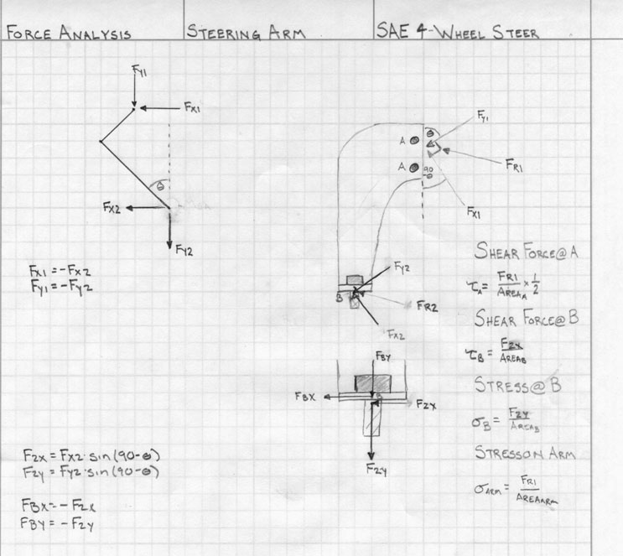
Force Analysis Graphic for Steering Arm: Included for Notation Purposes
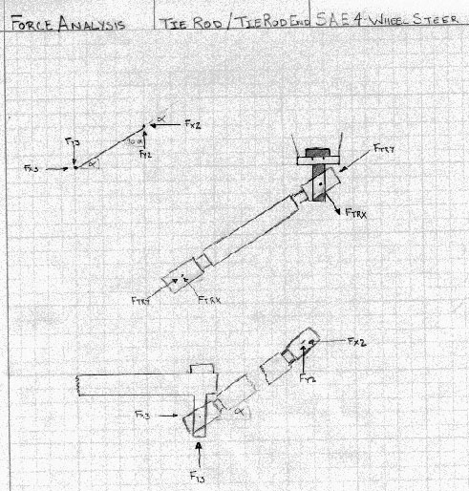
Force Analysis Graphic for Tie Rod/Tie Rod End: Included for Notation Purposes

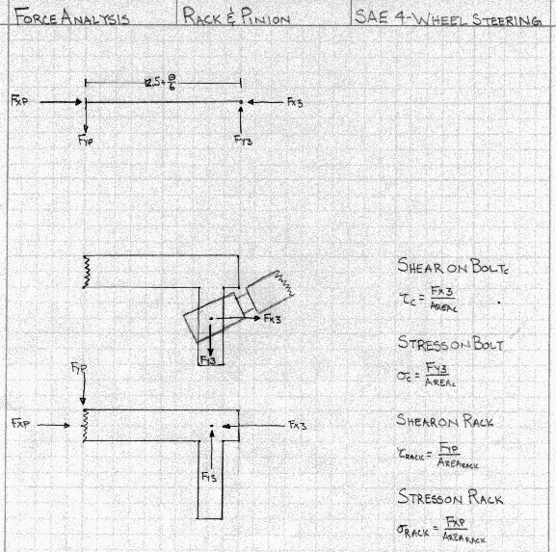
Force Analysis Graphic for Rack: Included for Notation Purposes

Appendix VII: Force Analysis
0 Degrees

10 Degrees

20 Degrees

30 Degrees

Appendix VIII: Graphs

Appendix IX: Engineering Drawings

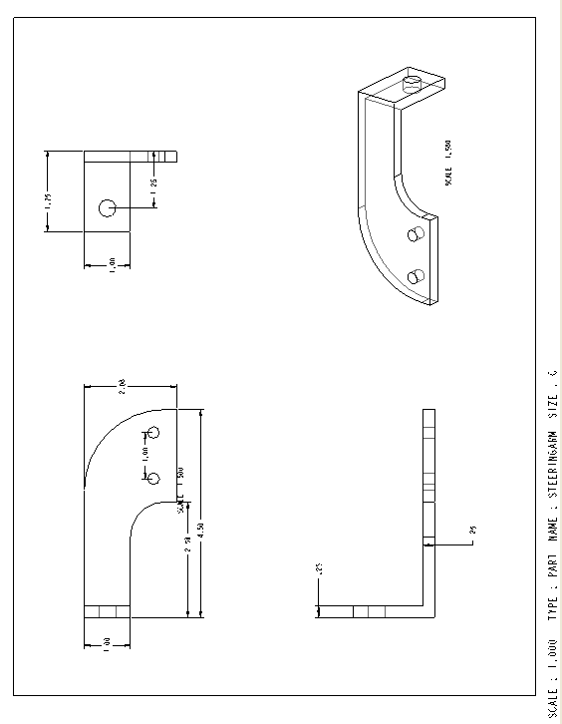
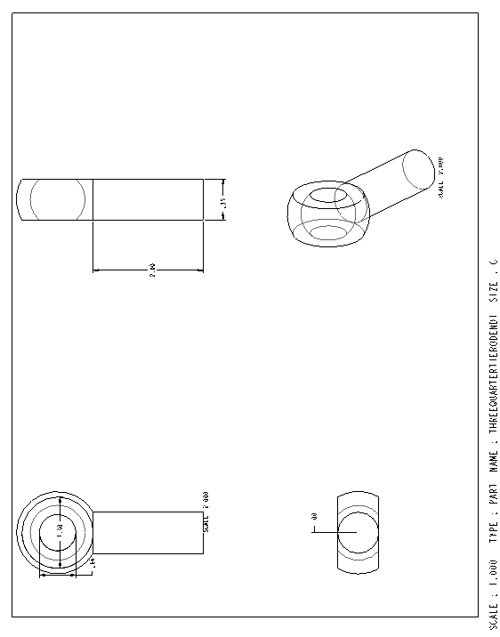
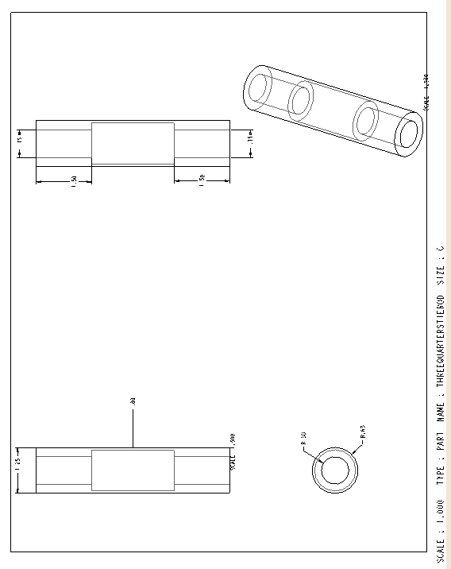

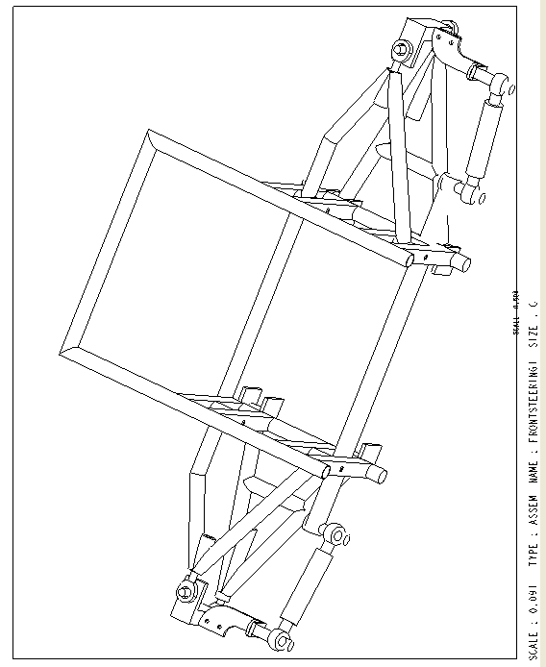

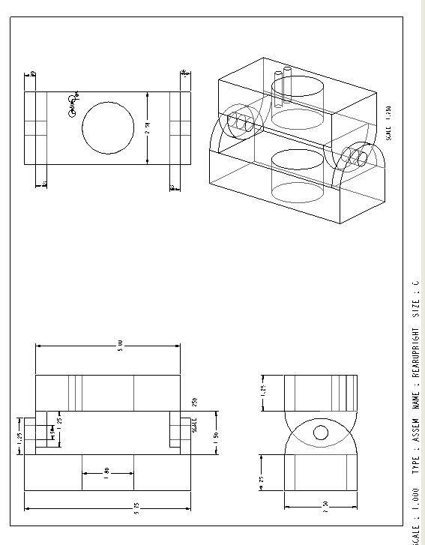
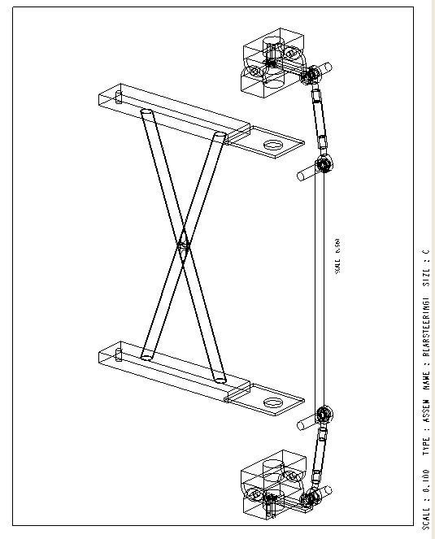

Appendix X: Final Product Specifications
Final Specifications
________________________________________________

Component | Specification
Turning Radius | 6.5’
Forces to Withstand | 5600 N
Budget | $500
Front Wheel Angle(max) | 30 degree
Rear Wheel Angle(max) | 15 degree
Front Rack Travel | 5”
Front Rack Length | 25”
Steering Arm Length | 3.5”
Tie Rod Length | 7.07”
Rear Rack Travel | 2.5”
Rear Rack Length | TBD”

Appendix XI: Contact List
Contact List
________________________________________________

Sponsor:

Dr. Patrick Hollis
SAE Faculty Sponsor
(850) 410-6319
hollis@eng.fsu.edu

Patrick Middleton
SAE President
(850) 656-3618
pmiddleton@eng.fsu.edu

Graduate Assistant:

Gary Osterholt
(850) 445-8877
gary@garyosterholt.com

Team:

Clyde Baker
(850) 562-5958
bakercl@eng.fsu.edu

Ken Brown
(850) 321-8833
kjmbrown@yahoo.com

Alex Cherukara
(850) 321-9226
acer1001@yahoo.com

Kevin Eady
(850) 443-3678
eadyke@eng.fsu.edu

